

State Level Workshop on

Water, Sanitation and Hygiene(WASH) in schools

**Organised by:**

**SarvaShikshaAbhiyan (SSA), RGSM,Chhattisgarh and UNICEF**

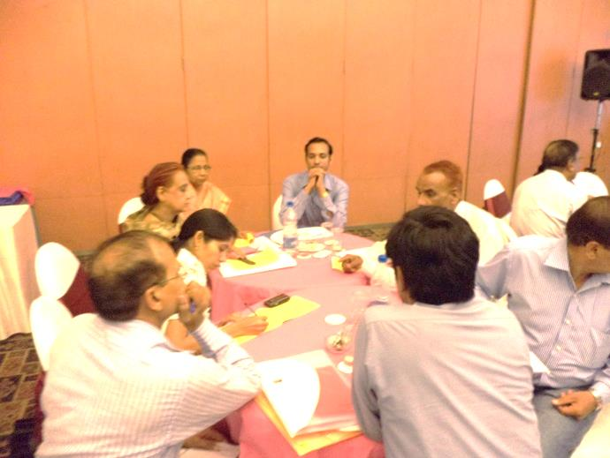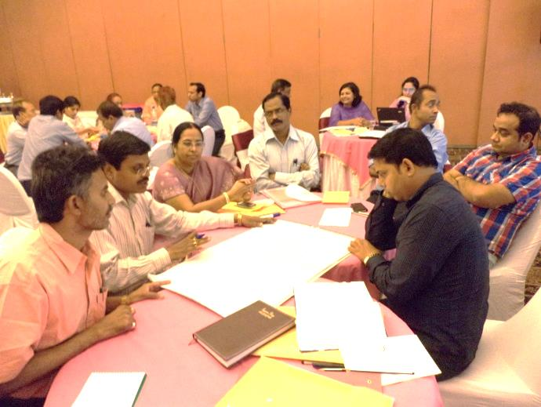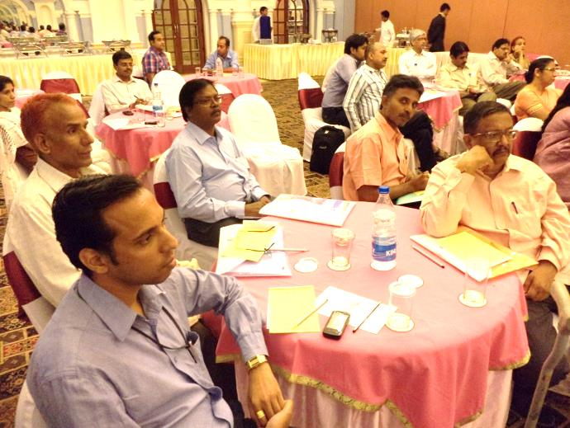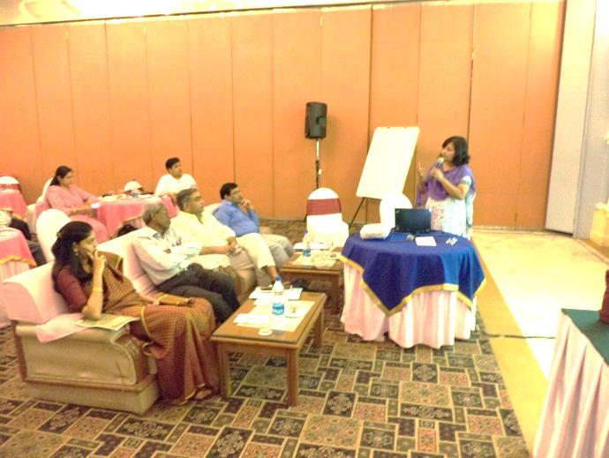

**Hotel Babylon International, VIP Road Raipur, Chhattisgarh**

**March 23, 2013**

**Contents**

|  |  |  |  |
| --- | --- | --- | --- |
| **S.No.** | **Topics** | | **Pages** |
| 1 | Background of the Workshop | |  |
| 2 | Sessions and Discussions | |  |
| 2.1 | Session-1 Inaugural session | |  |
| 2.2 | Session 2-Technical session | |  |
| 2.3 | Session-3 –session by the SSA | |  |
| 2.4 | Session-4 Group work | |  |
|  |  | |  |
|  | | | |
|  | | **Annexures** |  |
| Annexure 1 | | Agenda of the Workshop |  |
| Annexure 2 | | List of participants |  |
| Annexure 3 | | District –wise report card of State on WiS |  |

**Abbreviation Used**

APC Assistant Project Coordinator

ARSH Adolescent Reproductive and Sexual Health

ASER Annual Status of Education Report

ASHA Accredited Social Health Activist

CCDU Communication and Capacity Development Unit

CG Chhattisgarh

DHS Directorate of Health Services

DISE District level information on school education

DPC District project Coordinator

DPI Directorate of Public Instructions

DWCD Department of Women and Child Development

HS High School

HSS Higher Secondary Schools

IAS Indian Administrative Services

IE Inclusive Education

IEC Information, Education, Communication

JSY *JananiSurakshaYojna*

KGBV Kasturba Gandhi BalikaVidhyalaya

MD Mission Director

MDM Mid Day Meal

NBA Nirmal Bharat Abhiyan

NRHM National Rural Livelihood Mission

OOSC Out of School Children

PR&RD Panchayati Raj and Rural Development

RES Rural Engineering Services

RGPSA Rajiv Gandhi PanchayatSahashktikaranAbhiyan

RGSM Rajiv Gandhi Shiksha Mission

RTE Right To Education

SC Scheduled Caste

SCERT Scheduled Tribes

SED School Educational Department

SHRC State Health Resource Centre

SLMA State Literacy Mission Authority

SPO State Project Office

SSA SarvaShikshaAbhiyan

SSHE School Sanitation and Hygiene Education

ST Schedule Tribe

TSC Total Sanitation Campaign

UNICEF United Nations Children's Fund (formerly United Nations International Children's Emergency Fund)

WASH Water Sanitation and Hygiene

WIFS Weekly Iron and Folic Acid Supplementation

**Background of the workshop**

The availability of safe water and adequate sanitation facilities and hygiene education are one of the key determinants for learning and health of children, especially for girls. The availability of functional facilities and hygiene behaviours are not only linked to physical, mental and social health but have far reaching impacts on economic and political development in a region.There are many studies that point to the fact that if adequate water and sanitation facilities and hygienic behaviors are not present in schools they can become site for spread of infections, since they are meeting places for children for 3-4 hours per day.

Rigorous efforts of various stakeholders over the years with Government of India has led to increased emphasis on WASH in Schools (Water, sanitation and hygiene in schools that is in synchronization with global efforts to realize our vision of a world where all children go to schools that provide a safe, healthy and comfortable environment where children grow, learn and thrive.

In keeping with the above realization and the commitment of achieving the Millennium Development Goals (MDGs) India enacted the Right to Education Act in 2009. The RTE entails free and compulsory education for all in a “child friendly learning environment”. The RTE recognizes the importance of functional water and sanitation facilities in schools for healthy learning atmosphere. Based on the Right to Education, the Supreme Court of India has issued 2 directives, since October 2011 to the Education Departments across all States in the country for providing safe water and separate toilet facilities for girls in all schools. Since its enactment the RTE Act has led to an improvement of school enrolment and gender parity however; the number of schools with functional water and sanitation facilities is showing a slow improvement.

In light of present scenario there is a suitable enabling environment for understanding the importance of WASH in Schools. In April 24-27, 2012, a South Asia Regional Conference was organized in Delhi in joint collaboration with the Ministry of Drinking Water and Sanitation, Government of India, Ministry of Human Resource Development, Government of India and UNICEF. The objective of this conference was to accelerate the efforts in the country and learn and share experience on WASH in Schools. Around 200 participants from South Asia, including Afghanistan, Bangladesh, Bhutan, India, Maldives, Nepal and Sri Lanka participated in this conference that was one of the biggest events on WASH in Schools in the region.

The District Information System for Education for 2011-12 in Chhattisgarh shows that 9% schools are without functional drinking water facility and 40% schools are without any toilets facility and 64% schools without provision for separate toilets for girls. Even in schools where drinking water facilities are available, only 71% (less than 3 out of 4) are functional and the same trend applies to sanitation facilities where only 22% of available facilities are functional. The DISE data does show an improvement of coverage of sanitation facilities from 61% in 2009 to 72.67% in 2011 which may be attributed to the actions taken at the State level based on the Directives issued by the Supreme Court of India.

Despite the importance of WASH in schools any dedicated intervention is not present in Chhattisgarh in both PHED and SarvShikshaAbhiyan, the emphasis continues to be on construction of water supply and sanitation infrastructure with miniscule focus on hygiene education and maintenance of the WASH facilities. This may be attributable to some extent, firstly to the lack of prioritization of hygiene education and maintenance of WASH facilities in schools and secondly to lack of complete ownership of WASH in schools by both these departments.In view of the above situation WASH in schools has to be brought to the core of policy making and it has to be implemented in the State by both the PHED and RGSM. SSHE is potent mechanism to ensure adoption of hygienic behaviors in communities since children are message carriers for their families hence the social norms related to sanitation and hygiene will also be addressed in the long run.

In order to highlight the importance of WASH in schools and start the work on an action plan for this, a one day state level workshop was organised at Hotel Babylon International in Raipur on March 23, 2013in joint collaboration of SSA, Chhattisgarh and UNICEF.

**Key Objectives of Workshop**

* Consensus building in state on WASH in schools as envisaged in the RTE.
* To review the progress on WASH in schools in state in light of RTE by identifying the key gaps and challenges in WASH in Schools in Chhattisgarh, related to access, coverage and functionality, and girls’ toilets and develop mechanisms to address these.
* Develop actionable points for WASH in schools program in state which may include strengthening the WASH in School monitoring system to create evidence and promote sustainable WASH in schools and addressing gaps in State for following the norms and standards related to WASH.
* Initiation of State Resource Group on WASH in Schools in Chhattisgarh

The workshop was brought together 41 participants across different Departments like Education, PHED, Department of Woman and Child Welfare, Dept. of health and family welfare, Tribal Welfare, SCERT and State Health Research Center. The participants together worked upon the solutions for two of the critical problems for WiS in State.

# Key Questions focused upon during the workshop

* How to work across sectors to increase investments in child-friendly schools, including child- and gender-friendly WASH facilities in all schools?
* How to bring on a common platform the stakeholder Departments having interventions related to school health, hygiene to ensure comprehensive planning and allocation of budgets for sustainability of Water and Sanitation Facilities and Hygiene behaviors?
* How to monitor WASH-in-Schools programs alongside quality indicators like functionality, suitability for children with different needs, quality of infrastructure, child-and gender-friendliness, etc. What are the examples of simple, sustainable systems of monitoring?
* How do we contribute to the evidence base nationally and globally, for informed decision-making and effective distribution and use of funds?  How do we gather and share comprehensive data, disaggregated by gender, access and quality of services?
* How do we demonstrate quality WASH in Schools program so that schools create conditions where children themselves are agents of change in their families and communities?
* How do we collect data for tracking progress, for determining accountability, for evaluating project effectiveness, for learning and advocacy, and to inform planning?

**Sessions and Discussions**

# SESSION I -Inaugural Session

The workshop started with a welcome address and Introduction to the Objectives by WASH specialist from Chhattisgarh Office of UNICEF. This was followed by a key note address by the Secreatry Education, Mr K. R Pisda and then by the Chief of State office of UNICEF, Mr AsadurRahman, The Project Director SaravSHikshaAbhiyan and RastriyaMadhamikShikshaParishad, Mrs ReenaKangale made the inaugural address followed by speech of the Engineer-in-Chief of PHED.

**Key Note Address by Secretary, School Education Department, Education, Government of Chhattisgarh, Raipur:**

Mr.K. R. Pisda, (IAS), Secretary, School Education Department, Education, Government of Chhattisgarh extended a warm welcome to all participants. He said that:- the availability of the basic facility at the school and the improved hygiene behaviours of children are very critical for a healthy school environment. He said that it's our duty to inculcate good habits among the students to ensure that they become good citizen.He also said that the schools are being run through School Education Department and Department of SC & ST Welfare in the State, while the services on health and WASH are supported through the Health& Family Welfare Department and PHEDrespectively. He added that there is a need of effective coordination among various departments. He added thatensuring a healthy learning environment was a huge task and we need to plan across Departments and act as per the requirement.

He indicated that there is a need of greater improvement in the infrastructure while focussing on the education and health. He shared that there are many facets of this issue. There was a need of greater focus and understanding on this issue during the workshop. He wished that workshop would meet its objective and will assist in bringing some of the core issues to lime-light.

**State Chief UNICEF, Chhattisgarh UNICEF:**

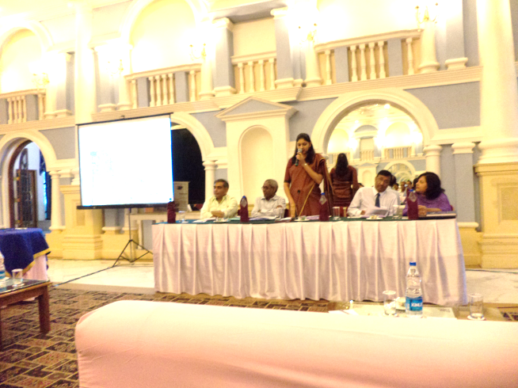Mr. Asadur Rahmanstarted his address by welcoming all participants on behalf of UNICEF. And thanking all key Departments for their presence in this crucial workshop. He said that WASH in schools was an important requirement for creating a child friendly learning environment. He mentioned thatUNICEFwill support the Government on this crucial initiative as a shadow, with the Government taking the lead t ensure that desired improvements happen in status of WASH in school. He wished that workshop would contribute towards achieving synergy between different Government Departments and plan for improved hygiene behavior, health, learning of the children and sustainability of WASH in the school.

**Inaugural address by Mission Director, SarvaShikshaAbhiyan (SSA):**

Ms.ReenaKangale (IAS), Mission Director, SSA, State Project Office (SPO), Rajiv Gandhi Shiksha Mission (RGSM), referred to the objectives of the workshop shared that it is of importance to work on the issues of water, sanitation, hygiene, health for a healthy child and healthy next generation.

She drew the attention of the participants towards the high IMR and malnutrition level among children in Chhattisgarhas compared to National average. She sharedthat the poor hygiene and sanitation in communities and school surroundings makes the children expose children to multiple infections like Diarrhoea, Cholera,typhoid, etc which manifest themselves as absenteeism, malnourishment and stunting in children. She said that schools temples of learning, but cam become disbursement points for infections if they have unsanitary surroundings and poor hygiene environment. She questioned that in situation when 50% of the children were malnourished it was difficult to have health generation of citizens of tomorrow. With reference to the provisions under RTE, she enlisted the benefits of having a good physical learning environment on issues likechild hhealth, school aattendance and learning achievements of children, promoting gender equity and reaching the communities with safe water and sanitation messages.

In her presentation she dealt with the comparative status of India (Rural) and Chhattisgarh (Rural) on drinking water, toilet related parameters based on the ASER survey of 2012. The status indicated that in terms of drinking water facility in schools Chhattisgarh is in a better situation with (79.2% of the schools having the drinking water facility) than India (73%). In terms of toilet coverage, she said that the SSA had provisioned and completed girl's toilet in 97% of schools, while for boy's toilet we need to still improve the coverage level (from 48% present level). Referring to the status of low usage of Sanitation facilities in schools as per ASER 2012, she added that we needed to focus on improving behaviours of students and maintenance of WASH facilities that were the main impediments in functionality.

She added that schools students are message carriers for their families and if they are providedmessages of hygiene and sanitation at school they can influence their family, contributing to a health society with low disease loads. Referring to research studies of UNICEF, she emphasised the relevance of WASH in school owing to the fact that diarrheal morbidity can be substantially reduced by simple interventions like:

* Hand washing with soap 44%
* Household water treatment 39%
* Sanitation 36%
* Water supply 23%
* Source water treatment 11%

Indicating the benefits of above intervention, she said that we focus on hand washing with soap on Global Hand washing (15th October, 2013) but there was a need to sustain this practice throughout the year in all schools. She also presented the status of coverage of the girl's toilet in the High School (HS) and Higher Secondary School (HSS)level and said that- there is also an urgent need to improve the coverage of girls toilet in HS/HSS level. She concluded by saying that together, we will be able to sort out the issues to make the school environment healthy for children.

**Address by Engineer in Chief, PHED, Government of Chhattisgarh :**

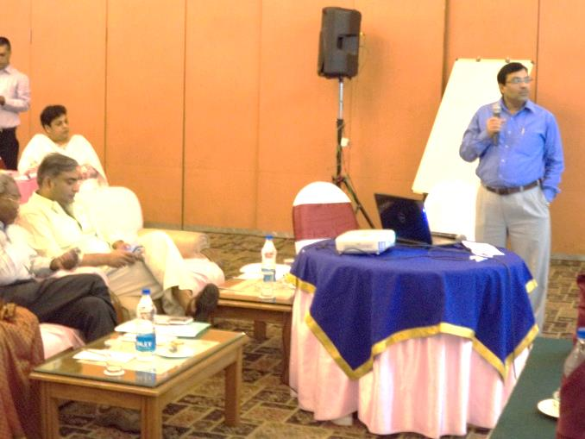Mr. T. G. Kosariya, Engineer in Chief, PHED informed the gathering about the role of PHED in ensuring adequate water, sanitation and hygiene in schools. He said that safe water, sanitation and hygienic behaviours are critical for health. He said we need to think about improving use and maintenance of the toilet units. He said that presence of sanitary conditions in rural schools was one of the criteria for the village to be declared as eligible for the Clean schools award or Nirmal Gram Puraskar(NGP)

He stated that prior to 2011 the SSA entrusted that task of construction of WASH facilities in schools to the PHED but after that the trend has changed although the PHED still assists in process of installation of water points in schools. He added that under the NirmalBharat Abhiyan guidelinesthe PHED can only construct toilets if the school building was constructed before 2007 and did not have any toilet. Mr Kosaroya said that the main challenge in maintenance of toilets in schools was the availability of water supply within schools, he further added that the PHED had tried to address the problem of water availability in schools through force lift pumps and also solar water pumps.

Mr Kosariya said that for WiS the availability of water was not a major challenge but the water quality was proving to be problem. He drew the attention of the forum towards challenge of poor quality in rural areas in State that also impacts schools. He mentioned that the total number of habitations to be provided water in State is 72,231 out of which 8815 or 12.2% habitations have Water Quality problems. Majority of WQ problems pertain to presence of Iron which is present in 95% of habitations and the second biggest problem was that of fluoride that was present in 330 of habitations. The problem of fluoride had adverse effect on health of children as it led to dental fluorosis. MrKosariya stated that the number of WQ affected drinking water sources is increasing in the state over years, due to reducing ground water level leading to increase in concentration of the chemical contaminants.

He emphasised the need for coordination at all levels like inter-departmentally and at village level amongparents,teachers, community, health frontline workers, panchayat and PHED staff to ensure safe water and sanitation for children in rural schools.

# Session II- Technical session

**WASH in Schools: The context and key priorities by WASH Specialist, UNICEF New Delhi:**

Ms.Mamita Bora Thakkar, WASH Specialist, UNICEF New Delhi started her presentation by sharing the advantages of having sustained WASH in Schools:

* Improved school attendance, health and cognitive development;
* Greater girls’ participation in school;
* Positive hygiene behaviours that may last for life;
* 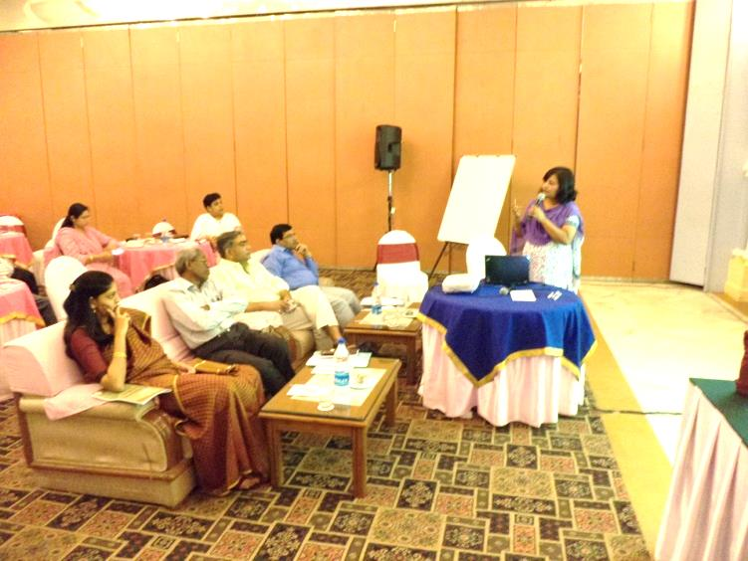Outreach to families and communities with hygiene and sanitation messages, through the participation of students in hygiene promotion.

She recounted the research findings that linked the WASH in schools with primary school attendance, health and cognitive development:

* Diarrhoea reduction through improved sanitary facilities could be : 34 %
* Washing hands with soap may help in: diarrhoea reduction by 40%, respiratory infections reduction by 16%, number of school days lost reduced by 25-50%.

She informed that worm infestations are linked to lack of sanitation and hand washing practices and this was an area of concern since an estimated 47% of children (ages 5-9) in developing world suffer from worm infestations. She shared that in a small study in slums around Delhi - it was found that 79% of the children had worm infestations and mentioned that this was more or less the case with other areas in the country; therefore hand washing with soap should be promoted without exceptions amongst all school students.

She emphasized that sanitation facilities in schoolsare much more needed for girl students and if present these should be friendly to girl childrenbecause in case of adolescent girls due to menstruation about 7 days per month and about 84 days per year could be lost in absence of a safe place for changing menstrual cloth. The absenteeism from school for adolescent girls can have manifestations like female illiteracy and associated problems like poverty and increased likelihood of child mortality. She added that poor menstrual hygiene can adversely affect the health of adolescent girls due to infections. She further emphasized that construction of toilets for girl students should be done at safe locations in schools to avoid threat of abuse and violence.

Mamitafurther mentioned that "Positive hygiene behaviours may last for life**"**since long-term effects of community hygiene education programmes for both adults and children indicate that sustained hygiene behaviour lasts at least 7-9 years beyond the end of an intervention. She mentioned that once hand washing with soap becomes a part of daily routine in childhood it tends to last throughout life. This is the reason that WASH in schools can facilitate a healthy society for future.

She provided information on how children can be agents of change - by taking the hygiene and sanitation related messages to their families and communities. She highlighted the crucial role of teachers in providing hygiene and sanitation knowledge to students. She referred the experiences from Nepal - where the School Led Total Sanitation contributed significantly to the change in community sanitation behaviour.

After sharing the benefits of WASH in schoolsMamitainformed about theenabling environment for WASH in Schools in India through the following:

* Enactment of Article 21 A of Constitution of India. RTE Act 2009 and the Supreme Court's deadline for all states to ensure water sanitation facility in schools by 31st March 2013.
* Thegoal of SarvShikshaAbhiyanfor universalizing elementary education also had WASH
* under Nirmal Bharat AbhiyanWASH in schools was an essential critiea for any panchayt qualifying for the Nirmal Gram Puraskar
* recommendations ofTheSouth East Asian Conference on Sanitation (SACOSAN) 2011

She presented a spatial map of States of India showing that Chhattisgarh is also among states, having lower coverage of school toiletsas compared to the national level. As per CMS survey 2010, the National average was one school toilet on an average serving about 89.5 children, and at that time Bihar, West Bengal were having more than 100 school students being served by a single toilet. Chhattisgarh was laso falling in the same category with more than 100 children being served per school toilet

She further added that every second toilet happens to be to a non functional toilet, in India making it challenge to ensure functionality of all school toilets as funds get allocated under SSA for construction of new toilets and not for maintenance of existing ones. She highlighted the challenge of proper operation and maintenance of the WASH in schools and informed that UNICEF was advocating at national level for allocation of the dedicated fund for this crucial need.

She drew the attention of the forum towards the inconsistency of the available data from MIS on the coverage and Use and maintenance of the data. This was basically related to reported data under the MIS of Ministry of Drinking Water and Sanitation, the data reported by the Education Department under the DISE and the data of ASER(done by NGO-PRATHAM). Some of the common challenges were summarized as:

* Lack of sustainable government funding mechanisms – for operation and maintenance.
* Decline in functioning of wash facilities after construction.
* Limited practising and sustaining hygiene in schools and beyond.
* 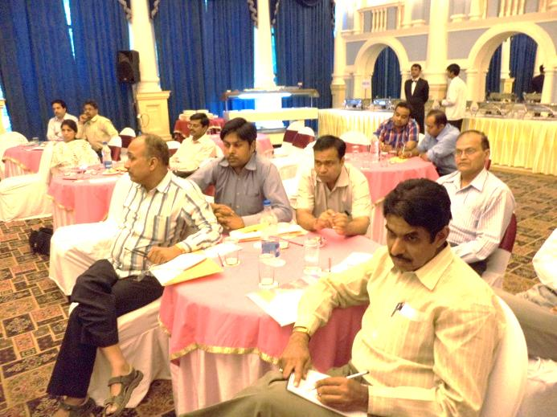Data inconsistencies.

With reference to availability of water in schools Mamita mentioned thatalthough field test kits and various measures were taken by the Government to test the water quality at field level, but still there was a limited understanding of Water quality at school level; this had led to limited work on ensuring supply of potable water in rural schools.

She emphasised on need of water quality education at the field level. She added that, there existed possibilities of improving services under various programmes such as - ARSH, MHM, School health under NRHM, SSHE in NBA.

She further added that functionality of hand pumps and overhead tanks is also crucial in ensuring water availability in the toilet for proper use and maintenance.

In view of the above situation some of the priorities under WASH in schools were shared as:

* **WASH in schools is an integral aspect of education**: The WASH should not be seen as an additional activity in school, but needs to be integrated within the system.
* **Establish National Standards for WASH in Schools**: There is a need to further specify and define the minimum standards for WASH in schools at the national/ state level.
* **Establish menstrual hygiene management mechanisms:** Thisneeds to be provisioned and ensured in schools starting from the middle school level (6th standard onwards).
* **Establish operation and maintenance mechanisms for WASH facilities**
* **Practice good hygiene- handwashing in all schools:** The hand washing with soap needs to be institutionalized along with the Mid Day Meal. She quoted UNICEF work in 3 other Indian states namely Madhya Pradesh, Assam and West Bengal where technical support was ongoing for demonstrating models to implement and sustain this practice. She added that the Ministry of Human Resource Development in India was likely to issue new revised MDM guidelines that will make it mandatory for inclusion of hand washing with soap.
* **Establish EMIS as the common, reliable, database**: This may be devised on the defined parameters and itshould be based on sound & quality field database reporting system.
* **Monitoring system for WASH in Schools access, functionality and usage:** There was a need of capturing the usage and maintenance of related data at the cluster level and the staff involved in data collection need to be oriented for it.
* **Raise the profile of WASH in Schools:** The requirement of WASH in schools needs to be understood and prioritized in light of its intrinsic linkage to children's health and academic performance.

To explain WASH in schools Mamitashared a simple model as:

She then shared examples of Essential Health Care Programme that has been developed in Philippines and successfully implemented in other nations as Cambodia, Indonesia. The Hand wash facilities promoted by these countries to institutionalize the hand washing with soap in schools were presented before the participants with its relevance and practicality to the Indian context. She emphasised that even if a few key action points under WASH are identified and focussed that would contribute significantly towards the desired outcome for improved children's health.

**Status of WASH in Schools in Chhattisgarh by WASH Specialist, UNICEF Chhattisgarh:**

Dr. Pratibha Singh, WASH Specialist UNICEF, Chhattisgarh made a brief presentation regarding the status of water, sanitation and hygiene education in rural primary schools in Chhattisgarh. She mentioned that as per District Information System for Education for 2011-12 in Chhattisgarh (Rural) :

* 9% schools are without functional drinking water facility
* 40% schools are without any toilets facility
* 64% schools without provision for separate toilets for girls.
* In schools where drinking water facilities are available, only 71% (less than 3 out of 4) are functional and the same trend applies to sanitation facilities where 22% of available facilities are non- functional.

With sharing the above status, She presented photographs of drinking water facility in the schools which reflectedthat :

* There was poor water drainage nearby drinking water sources
* All the tasks related to water in schools are done near asingle hand pumpincluding cleaning utensils by students and cooks of mid-day meals and hand washing at peak use hours, besides collection of water for cooking and cleaning of toilets
* In many some instances water supply points become non-functional with high lag time for repair.

She also presented some snap-shots of sanitation facilities having challenges like:

* Lack of proper maintenance of unit (getting least priority in O & M)
* Toilet are in poor usable conditions (lack of proper hygiene inside)
* Lack of adherence to design & poor quality construction affects long term functionality of toilet.

Based on the ASER data for last 3 years she explained that the non usability of toilet is 32.7% (in 2012), that has shown a reduction over year but yet to be focused. For the girls toilet the ASERdata shows that nt level of non-usability of toilet was15.3%, while another 8.4% of the toilets were found locked. She further presented comparison among districts to highlight coverage gaps in WASH infrastructurebased on availability as well as functionality, ranking of the districtsbased on WASH parameters (both composite indexbased as well as separate WASH parameter based).

She thenenlisted following challenges for WASH in schools in State:

* The technology and design used in construction of school toilets lacked ingender, disability and child friendly considerations. It was only in 2012 that the toilet for physically challenged persons were provisioned under SSA in State as per design shared by UNICEF
* Monitoring of WASH in Schools needs to be strengthen to incorporate indicators on conformance of the WASH facilities to the norms, usage of facilities and there was a need forimproving capacities to collect &analyze data.
* Improved data management is required for DISE and NBA databases as they need to be aligned to reflect updated effective coverage.
* Poor ownership of WASH facilities in rural Schools by the SMC and the PRIs
* Insufficient focus on menstrual hygiene management (MHM) in schools, especially at the upper primary school level.
* Lack of teachersand warden’s capacities for proving MHM related information to adolescent girls and lack of support material for imparting MHM trainings in schools.
* Sustaining appropriate hygiene behaviors (toilet uses, hand wash before meal etc) remains a major challenge in the WASH in Schools programme.
* Poor operation and maintenance of toilets and water sources impacts the functionality, usage and threatens sustained coverage.
* Many schools across state have broken, unused and malfunctioning toilets although the school building might be well maintained.
* A wide range of toilet designs are in prevalence due to lack of uniform norms that do not take the specific nature of WiS into account.

Following recommendations were made for improving WASH in Schools:

* Specific allocation of funds for WASH in schools under Annual School Maintenance Grant, since at present these funds are used for many different purposes and do not have a separate budget head for O &M of WASH facilities.
* Need of working in convergence between school health program & hygiene and sanitation program
* The existing monitoring mechanism of BRCs and CACs to capture usage of WASH facilities and practice of hand washing in schools with availability of soaps
* Provision of structures for mass hand washing and soaps in schools

After presentation from WASH Specialist, UNICEF, Chhattisgarh a small video clip demonstrating sustainability of practice of hand washing ina school was screened before the participants:

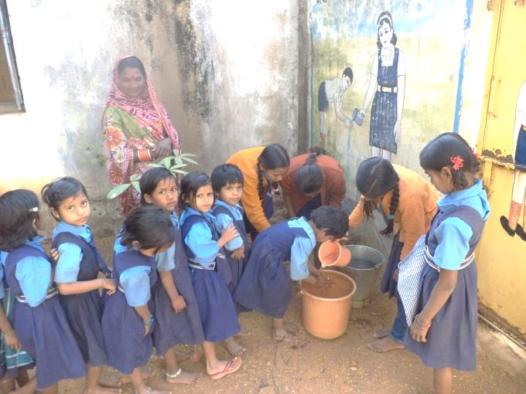**Vidoefilm - “Availability of infrastructure cannot be a hurdle when behaviour change has happened”**

The above learning is shown by an example from a ruralgirl’sprimary school in ManaBasti, Raipur.

In this short video film a case was taken up where the initiative of a school head mistress had ensured that children follow routine hand washing with soap before mid-day meals, in absence of hand washing stand and supply of soaps.

This film shows that based onawareness generation by RGSM staff for hand washing in schools the head mistress of this school had decided to ensure that students washed their hands with soap before mid -day meals. She had ensured availability of soaps in schools from the school management funds.

This school does not have a piped water supply and water for hand washing is collected from hand pump outside the school campus. A “hygiene group” has been formed in this school consisting of elder students who have the responsibility of carrying the water in buckets and assisting younger children in washing hands. This group has members in rotation to ensure that sense of responsibility is inculcated in senior students of school.

This example demonstrates that active teacher participation only can ensure that hygienic behaviours get adopted by students.

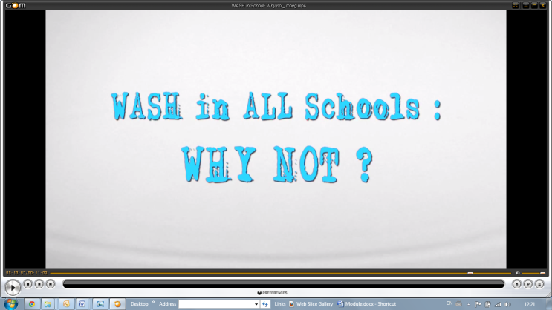**Screening of a short film "WASH in schools why not" ? :** A short film on **"WASH in All Schools why not",** by UNICEFwas screened after the above session. This film presented various aspects of WASH in schools including - field challenges in absence of WASH in schools, benefits of adopting WASH in schools. The movie showcased situations how the girl's education suffers due to non-availability of the separate toilet in schools. The film highlighted the key parameters of WASH in schools including design of toilet, proper operation and maintenance of toilet, hand washing platform,MHM awareness, provision of incinerator and monitoring of the hygiene habits at schools, building teacher's and children's capacity, role of child cabinet, ownership by community, enabling environment. The short film informed all participants about the need of building a healthy school environment.

After the screening of this the forum was opened for discussions, questions and answers.

**Open forum discussions on issues:**

* Mr. Bajrang Prajapati, APC, IE, SPO, RGSM raised the issue the issue of recent news reports about cases of the fluorosis in some parts of State and presence of arsenic in drinking water, if this was true then what is being done by the PHED to address the problem.

The representative from PHED responded the drinking water in some areas in State did have fluoride and arsenic above permissible limits. He mentioned that arsenic had been detected in drinking water in 11 villages in Rajnandgaon and at present the PHED had provided alternative water supply to these villages. He added that skeletal and dental fluorosis cases had been reported from Bastar region. Representative from PHE explained that the department also had the scheme of - "Jalmani"- for water insuring improved water quality in schools. The WASH Specialist UNICEF informed that under the NRHM also there was a program component for addressing the health effects of fluoride and arsenicosis.

* Dr. KhemrajSonwani, The Deputy Director NRHM mentioned that different Departments were collecting data related to schools (including health, nutrition, education and WASH) in different formats as per respective schematic requirements, but many a times mutually useful data was collected with different indicators. The concerned departments were unaware of these datasets and this was leading to confusion. He shared that there was a need to have a crosscheck of these formats for improving convergence on monitoring on the key parameters concerning schools including health and hygiene.
* MrPandey, district youth coordinator, from Nehru Yuwa Kendra, mentioned that to make the WASH in schools a reality in State there was a strong need for focussing on - Operation and Maintenance of the WASH units, strengthening of the child cabinet and ensuring convergence at the community level.
* 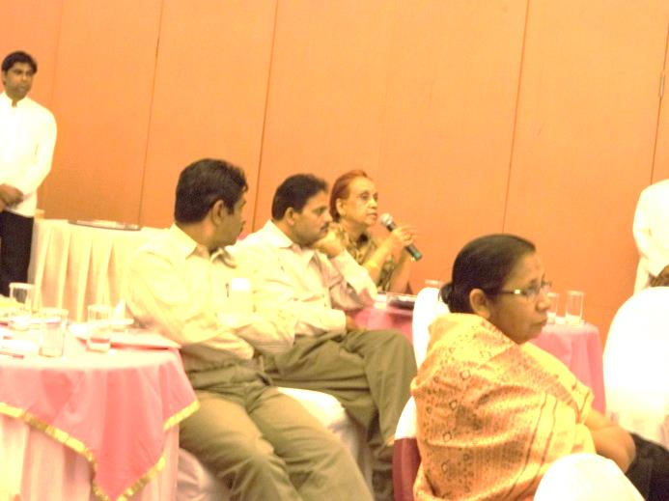Dr. Pratibha Singh, WASH specialist, UNICEF, Chhattisgarh stated that to strengthen the monitoring system to capture usage and maintenance of the WASH units, there was a need for inclusion these indicators in the reporting systems at the cluster level of SSA i.e the CACs. She further mentioned that inclusion of sanitation and hygiene behavioral parameters in school heath monitoring system may also be explored once all these Departments deliberate on a common forum.
* Smt. Kiran Singh, Assistant Director from the Department of Women and Child Development, - appreciated information provided during the sessions and initiatives like incinerator, but at the same time there was a need for introspection about the replication of these models in all schools in State, not just in one kind. She mentioned that availability of the sanitary napkins is a huge challenge as it is high cost intensive program if Government has the responsibility of providing these to school girls. She briefed about the latest "Sabla" programmeof the DWCD having a component for addressing the adolescent girl's needs related to MHM where there was a scope for greater coordination of stakeholder for effective implementation.
* The State Nodal Officer for ARSH, MrsL. J. Issac, from health department said that as a part of their recent programs they were providing sanitary napkin to adolescent girls through Mitanins (ASHA) at the village level. At present 10 districts of the state were being covered under this program, under which the MoHFW at Delhi was supplying Sanitary Napkins to PHCs in selected districts. The ASHA worker (mitanin) was required to collect these napkins form the PHCs and sell these at subsidized prices in rural areas. She added that the quality of the sanitary napkins supplied by the departments arecomparable to the ones available in the market, and it cost Rs 6/ per pack having 6 napkins. As per present arrangement under ARSH program of NRHM theMitaninwas required to sell this at the village level to the adolescent girls and obtain Rs 1 as incentive for each pack purchased. She shared that under Weekly Iron Folic System (WIFS) also the Health department was supporting 10 key services in 6 districts of the state that included MHM.
* Related to the above scheme of the NRHM the Additional Director, KGBV at State Project Office, SSA, RGSM asked the health department officials for possibility of proving these sanitary napkins to the KGBVs (girl's residential school) in those 10 districts at least where the department is supplying it through health system.
* The Nodal ARSH responded that in the above scheme the supply was only meant to be marketed through *Mitanin's* and the network of the Public Health Centers, hence it could not be provided to institutions
* MrsKiran, DWCD asked whether there was possibility of involving the Self Help Groups of women active within State in production of economical versions of sanitary pads that could be supplied to adolescent girls in rural villages and schools.
* Dr. Pratibha Singh, WASH Specialist, UNICEF, CG shared that in StateslikeMaharastra and Tamilnadu, there had been efforts to produce economical and subsidized napkins through the SHGs. These models had active support of UNICEF in Maharashtra and Tamil Nadu and in Chhattisgarh also these models were feasible. In case the production of sanitary napkins is done by the SHGs and local small scale units, there was a need to build inquality control mechanism to ensure compliance to quality norms.
* Dr. Sameer Garg, Chief training coordinator for Mitanins, from the State Health Resource Center (SHRC)mentioned that production of sanitary napkins by SHGs and community groups was a good option, since NRHM would not be in a position to supply these sanitary napkins indefinitely and even the current arrangement the number of packets to be supplied per month is limited.. He said that were still challenges while marketing of sanitary napkins through Mitanin- since in many cases users were taking napkin packets in credit from her and cost recovery was difficult part afterwards.
* Another representative form NRHM added further in this context that in some cases the Mitanin was not focusing adequalety on scheme for supply of sanitry napkins due to higher incentive in some other schemes like JananiSurakshaYojna (JSY).

**Involvement of Communities for WASH in schools, by State Chief UNICEF, Chhattisgarh:**

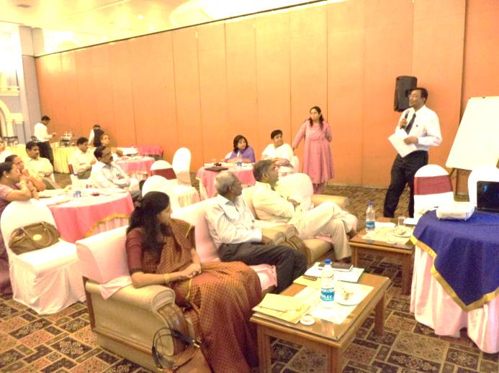Mr Asadur Rahman, the State Chief of UNICEF, mentioned that there were instances where parents were taking the responsibility of key requirements at schools. He said that there was a huge potential and possibilities, where community ownership at field may improve the conditions at schools significantly.

Some examples of involvement of communities for schools based on his experience in Srilanka:

* In one case the mothers of students providedtwo bottles of water in schools - One bottle for drinking water for children and another one bottle for plant,
* In other case- the mothers of students served as security guards in the schoolduring emergency situation.
* In another example parents had taken the responsibility of providing common mid-day meals in schools in absence of staff.

# Session-3 –Session by the SSA

This session was after lunch and it included the address by the MD of SSA, the Assistant Director at SCERT on role of different departments and communities in WASH in schools.

**Address by Mission Director, SarvaShikshaAbhiyan (SSA):**

MrsReenaKangale, theMission Director, SSA, RGSM said that in terms of provision of water and sanitation facilities in school a lot of investment has been made in past, which needs to be linked to desired results like usage, functionality and sustainability. She stressed upon the need to focus on behavioral change communication and capacity of key stakeholders for this purpose to improve on health and hygiene behavior among children in schools.

She said that it was good to see participation ofsenior officials from different departments like DWCD, NRHM, TWD and Panchayat Raj hence an joint action plan for 2013 -14 can be developed at this forum. She mentioned that there were new and emerging field level challenges like dependency of entire school on a single water source irrespective of strength of students and water quality problems like iron and fluoride which needed special focus and expertise. She said availability of water for usage of toilets wasa challenge in schools and options like solar powered and force lift pump can be explored where UNICEF can also support.

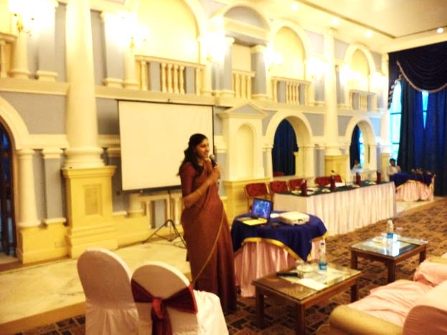She said that teachers and aaganwadi workers need to be trained about other aspects of WASH in schools like the maintenance of water and sanitation facilities in schools and aaganwadi, water quality testing, chlorine treatment, source safety, open defecation and its ill effects. She further added that it was essential to include health, hygiene messages in school curricula.

She emphasized on the importance of monitoring use and maintenance of the toilet (especially the girl's toilet). In context of Chhattisgarh she said that the poor literacy rates among women in some of the districts such as Bijapur, Narayanpur, Dantewada are amongst major challenges, which is linked to presence of WASH facilities in schools. The illetracy of women has multiple ramifications like poor health status when these women reach child bearing age. She said thatbesides problems with coverage of toilets in primary schools there exist gaps in coverage ofgirl's toilet at High School and Senior Secondary level that are equally important as they have adolescent students.

She said that there was a need to focus on nutritionalrequirements of adolescent girls along with intervention for anemia prevention. She explained that 80% women suffer from anemia in State resulting in malnourished children. She also mentioned aboutloss of nutrientsduring menstruation which makes it absolutely essential for adolescent girls to be equipped with awareness aboutnutrition. In this context she mentioned the need for integration of WASH intervention with the nutrition and health issues. She said that these can be pilotedthrough Health, Nutrition, Hygiene and Sanitation Program (HNHS approach).

She concluded her address with the stress upon the fact that the role of the communities was most essential in taking these interventions forward.

**Presentation by Mr.AshishDubey, Assistant Director, SCERT on**

**Role of Community, teachers and Panchayati Raj Institutions (PRIs) in SSHE in context of RTE :**

Mr. AshishDubey, started his address by saying that 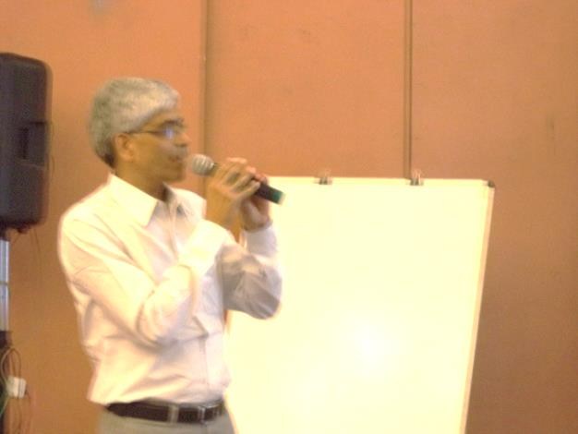just by construction of two basic facilities in schools it is not possible to ensure a healthy atmosphere unless the proper usage and functionality aspects are taken care of.

He shared a WASH action plan for schools with demarcation of roles and responsibilities of stakeholders.This action plan was bifurcated under toilet facilities, safe Drinking Water, clean campus/environment, personal Hygiene, MDM, Awareness Campaign. In his analysis he said while we focus onresponsibilities of WASHfor teachers and students the role of community and panchayats representatives is more critical as the teachers are overburdened with duties besides education.

The framework is as below:

| **Role of Whom**  **(Key issues)** | **Key Tasks** | **How to do these tasks** |
| --- | --- | --- |
| **1- Role of PRI :**   * **Toilet facilities-**Maintenance, Support material * **Safe Drinking water**- Maintenance, Support material, Drainageavailability/maintenance * **Clean Campus**- Cleaning System, Garbage storage, Disposal of Garbage * **MDM**- -Storage, Preparation,Service * **Awareness Campaign** - through Children, programs, Motivation | * Ensure timely construction of toilet & drinking water facilities as many schools were still not having functional WASH facilities * Ensure quality of construction & following-up of norms(through RES) * Keep dedicated funds for maintenance of facilities in schools * Ensure qualitative implementation of MDM program ascertaining hygienic preparation, servicing and cleaning mechanism | Through available allotment from concerned departments under:- 13TH finance commission, BRGF, MGNREGA, Basic needs programme (*Mulbhut)*  (Every Panchayat has a standing committee on Health, Education and Social Justice- This committee should be made responsible for school related activities) |
| **Role of Community (Through SMC)**   * **Toilet facilities -** Maintenance, Support material * **Safe Drinking water-** Maintenance,Support material,Drainage availability/ maintenance * **Clean Campus -**System for safe disposal of solid and liquid waste in schools. * **Personal Hygiene** * **MDM**- Storage, Preparation, distribution to students * **Awareness Campaign** | * Regular monitoring of cleanliness of school campus, toilets, water source and storage facility ensuring availability of material for cleaning. * Assisting schools in up-keep and maintenance of facilities. * Keeping track of effect of the awareness program behavioral change among children and parents. * Awareness campaign/discussions for health and hygiene of self and children * Creating environment of children’s, personal and family cleanliness and hygiene * Ensuring good quality and hygienic preparation and serving of Mid DayMeals | * Constitution of SMCs and having regularmeetings * Through regularly visiting schools * All members of SMCs can be assigned different days for visit ) * Ensure proper utilization of school grants(teacher’s grant, school grant, maintenance grant) * Preparing a comprehensive School Development Plan * Keeping in touch with PRIs for ensuring allocation of funds * Having a good coordination with teachers and administration * Mobilization of other community members   (Role of PRI, SMCMembers, Employees and Teachers should be clearly defined, and regulated) |
| **Role of Teacher :**  Except for providing resources and formulating programs under different schemes under PRI,teachers have a role to play in all the other aspects of implementation and monitoring of the SSHE program in schools | * Self realization of the importance of WASH in school * Be aware of the key elements like transition cycle, stages of hand wash, health and hygienic conditions and about diseases and causal factors * Continuous encouragement of children for eliminating bad habits /practices in schools as well as at home * Regular scrutiny of proper utilization of the facilities and maintenance mechanism * Coordination with other agencieslike PHED * Awareness, propagation and implementation through child cabinet, cultural events, social gatherings and other programs. | * Ensure availability of child friendly, gender sensitive facilities for sanitation, water supply, hand washing and solid waste management * Organizing awareness programs in schools on sanitation hygiene and health and creating environment of health/hygiene check of children in school * Educating children about benefits of good and bad practices on hygiene and health and discouraging them from open defecation * Focus on life-skill based hygiene education to develop adequate knowledge, skills and attitudes on hygiene education * Ensure orientation and participation of parents in keeping their children clean and maintain hygiene both at home and school * Ensure proper utilization and functioning of the facilities in schools through proper planning and disbursal of responsibilities of both children and staff. * Ensure availability of support materials for utilization of drinking water and sanitation facilities through proper utilization/out-sourcing of funds * Develop good communication with PRIs,SMC and community as a whole. |

# Session 4 Group Work and Discussions

**Proposed Steps for implementation of WASH in State --formation of State Resource Group(SRG) by Dr. Pratibha Singh, WASH Specialist, UNICEF, Chhattisgarh:**

The WASH Specialist, UNICEF Chhattisgarh mentioned that to further take up the task of WASH in schools a State Resource Group for Water and Sanitation is envisaged for facilitating coordination between the concerned departments namely Education, Public Health Engineering (PHE), Health, Department of Woman of Child Welfare, Department of Panchayati Raj & Rural Development and Tribal Development Department. The State Resource Group would help in addressing the issues related to sustainability of WASH infrastructure in schools through:

* Facilitating WASH In schools (WiS) programs on continuous basis. WiS involves awareness generation amongst students, parents and teachers for adoption of hygienic behaviors like usage of toilets, hand washing and general hygiene. The component of school heath also gets covered under this initiative and it is good opportunity for convergence with similar schemes of the National Rural Health Mission.
* Quality compliance of designs of WASH infrastructure with the norms and standards of Ministry Drinking water and Sanitation and ensuring uniformity of designs of infrastructure developed by either Department of Education or PHE.
* Taking steps for ensuring functionality, usage and maintenance of water and sanitation facilities in schools through orientation of the school management committees and child cabinets.
* Dedicated funding support for ensuring operation and maintained of WASH facilities in schools
* Development and implementation of a monitoring mechanism for water, sanitation infrastructure and sustainability of hygiene behaviors.
* NirmalShalaPuraskar or clean school awards: This mechanism of incentive for clean schools has an inbuilt monitoring mechanism and is being finalized by the PHED on lines of the NirmalVidlayaPuraskarYojana of the Government of West Bengal. The NirmalShalaPuraskar will require coordinated efforts of both Education and PHED.

In reference to the coordination and convergence needs she suggested the composition of SRG on School WASH as per the following:

* 5-6 members from SSA both from district and State level, district coordinators
* 3 officials from Nirmal Bharat Abhiyan of the PHED
* 2 officials from Tribal Welfare Department
* 2 members from National Rural Health Mission
* 1 member from the DWCD
* 1 member from DoPR&RD

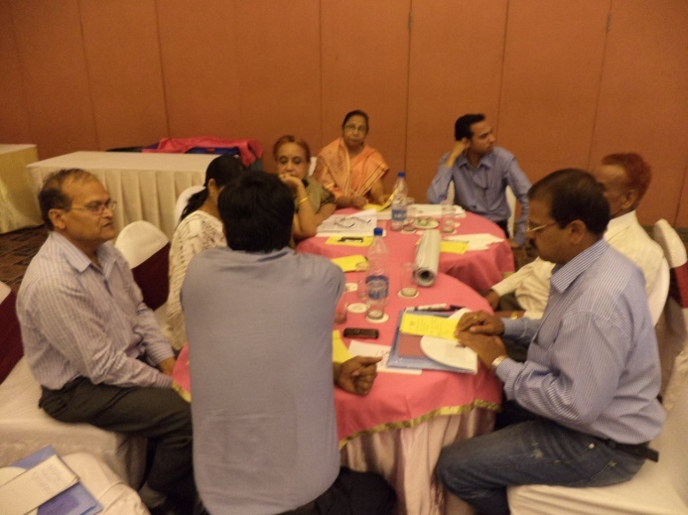After this session, she requested participants to organize themselves in two groups and the task for each group was displayed on screen. Each group took 45 minutes to discuss the issues and the representative from each group presented the salient points:

**Group No. 1:**

**Task: How to institutionalize the hand washing with soap in schools.**

The salient points included:

* One of the greatest challengesfor WASH in schoolswas in providingstructures for washing hands and ensure that soaps are available at all times.
* The funds for procuring soaps and construction of structures for hand washing may be obtained from following schemes like:

1. *Mulbhut*fund of the panchayat,
2. Backward Region Grant Funds (BRGF)
3. panchayat, funds from Mid Day Meal,
4. Other grants available at schools and support and contribution received from the community.

* For monitoring the hand washing with soap in schools: the group envisaged the key role of following:

1. Child Cabinet,
2. School Management Committee,
3. Standing committee of panchayat on - education, health and social welfare, panchayats& other key departmental representatives.
4. They also shared that the visit on a roaster/ random basis may be done by the community persons to monitor the adoption of hand washing behavoiurs
5. For institutionalization of hand washing under the support headthere was a need for: capacity building and sensitization of the key stakeholders. The group felt that if the community is made to understand the benefits of WASH and have an easy monitoring framework they will be able to take more responsibility

**Group No. 2:**

**Task: How to develop an MIS system for coverage, access and monitoring of the data on WASH (especially for uses and functionality.) and how to bring sustainability to WASH efforts in schools.**

The salient points included:

* 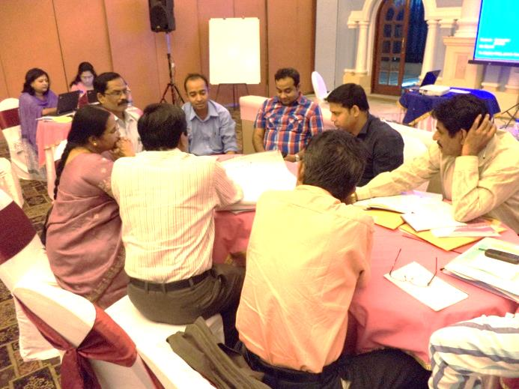Convergence among the department and vast area to be covered pose a serious challenges, while monitoring WASH indicators.The steps proposed by the team for effective monitoring of the progress on WASH included the following :

1. Establishing convergence between department at all levels (state, district, block, panchayat, institution)
2. To work towards achieving the real coverage (real time data MIS establishment)
3. Need of Action plan to achieve 100% WASH coverage (10 year's perspectives, with clearly defined targets)
4. Implementation of action plan with coordinated efforts (involving community- and focus on quality technical norms)
5. IEC regarding usage of the WASH units in schools was needed. The awareness program needed to be continuous and not just limited to the global hand washing day and it must be low cost, in local dialect
6. The monitoring of functionality of WASH units in schools was needed where key departments like PHED, Education and DWCD need to be involved at Block, District and State level and at the village level the SMCs and Panchayats need to be involved.

In order to do proper monitoringof WASH in schools the group made the following suggestions-

1. technology use (geo-tagging),
2. well defined objective parameters,
3. cross verification,
4. annual survey by independent external agency,
5. online web based- public domain,
6. Action taken report,
7. help line and toll free grievances redressal system

For ensuring the sustainability of the WASH in schools the group highlighted the key parameters and presented a model for sustainability of hygiene behavior as follows:

* Regular review of all WASH aspects in schools including access, usage, functionality, operation and maintenance
* Frequent sensitization of students and teachers through various means like- essay and painting competitions, slogan writing
* Fund generation and allocation (PPP, community involvement)
* For sustainability of the WASH in schools- there is a need of comprehensive approach where the accountability, usage and ownership needs to be clearly defined

One of the group member

After the group work the vote of thanks was extended to all participants for their active involvement in the workshopand it was emphasized that there was a need for joint action to take the WASH initiative forward- for ensuring healthy environment for children's learning.