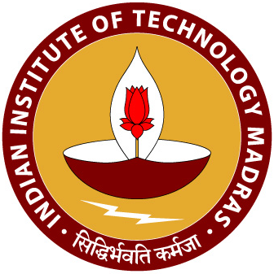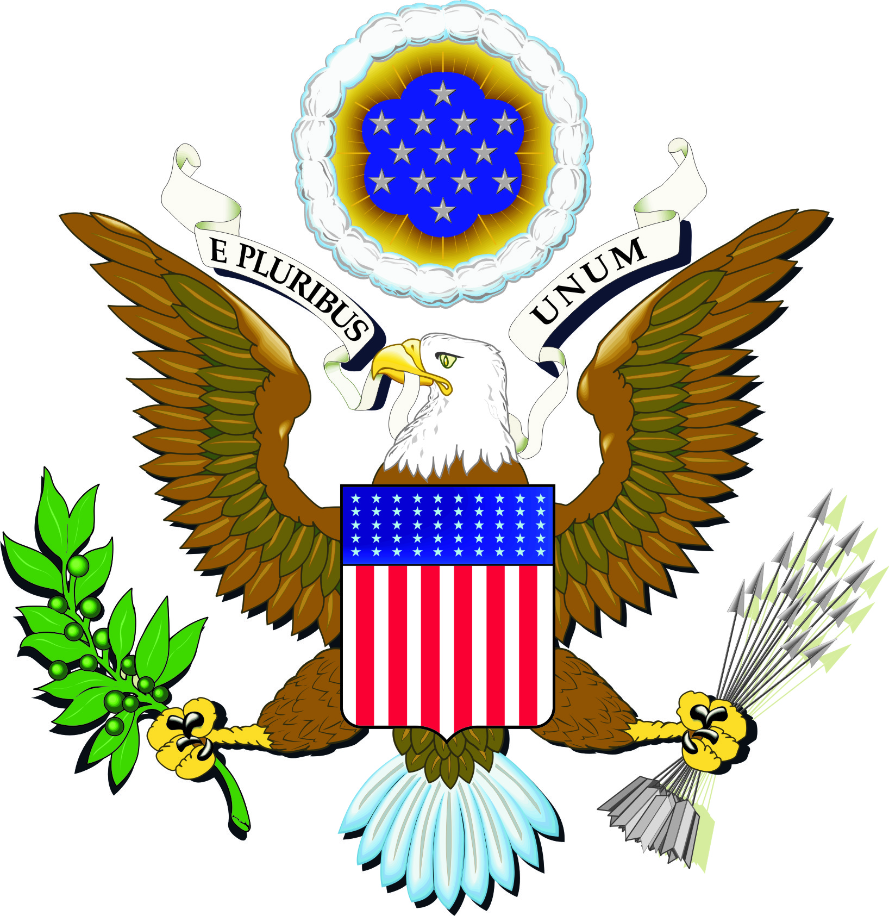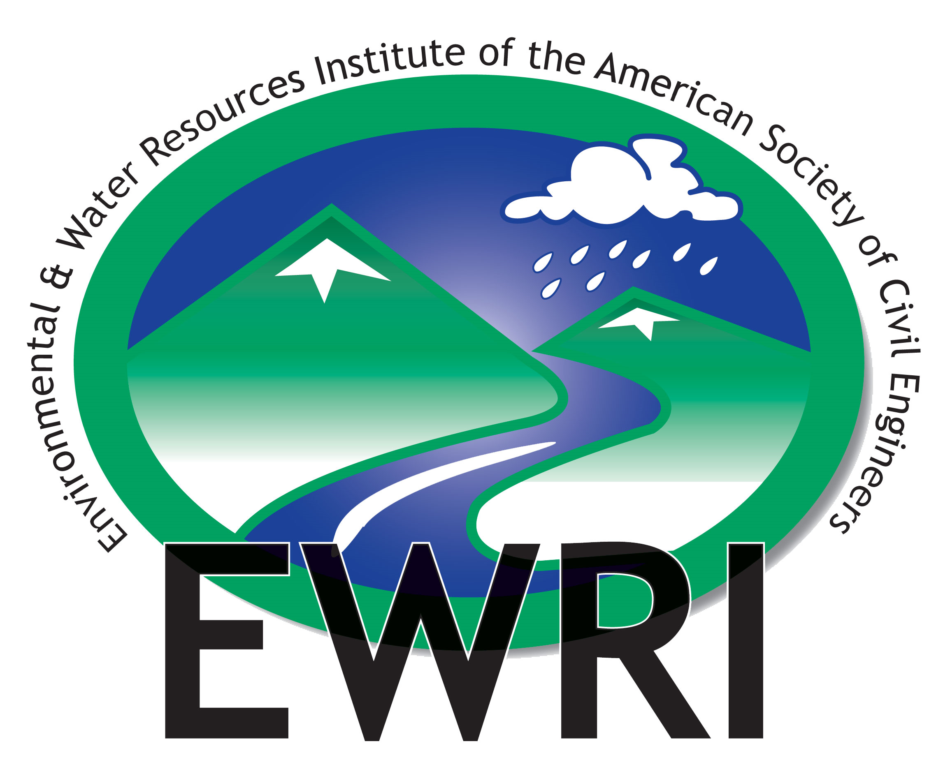

World Water Day Workshop 2010
Organized by ASCE EWRI South India Chapter and US Consulate-Chennai

Date: March 22nd 2010
Workshop Venue : Hall 2, ICSR building, IIT Madras
Program Schedule
9.15 - 9.45 a.m. Inauguration
Welcome Address by Dr. K. Rajagopal
Head of the Department, Civil Engg.

Program Description by Dr. Indumathi Nambi
Inaugural Address by Dr. M. Ravindra Srivatsava
Vice Consul, U.S. Consulate
9.45 – 10.45 a.m. Key note Speeches
1. Surface water bodies – Dr. M Ramalingam,
Director, I.R.S Anna University
2. Estuaries and Marshlands – Dr. S. Ramesh
Director, Institute of Ocean Management
3. Ground water – Dr. Thillai Govindarajan
Consultant, I R S Retd. PWD CE
10.45 – 11.00 a.m. Tea
11.00 – 1.00 p.m. Deliberations - Three Parallel Sessions at Building Sciences Block, IITM
1.00 - 2.00 p.m. Lunch
2.00 - 3.30 p.m. Presentations of the recommendations by Chair persons
Open discussions and consolidation
3.30 – 4.30 p.m. Plenary Session
Welcome Address : Prof. V.G. Idichandy
Deputy Director, IIT Madras
Chief Guest : Shri Phanindra Reddy I.A.S,
M.D and CEO of TNUIFS
Member Secretary of CRRT
Guest of Honor: Mr. Andrew Simkins
U.S. Consul General

